RECORDING MACROS IN EXCEL
Why using macro:
Excel uses a programming language called visual basic for application (VBA) to record our instructions. You don’t have to know anything about programming or VBA to create and use macros that will save our time and make our work easier. If you are performing a task repeatedly in Excel, you can automate the task using a macro. A macro is a series of commands and function that are stored in a Visual Basic module and can be called whenever you are in need to perform the task. For example, if you often enter long text strings in cells, you can create a macro to format those cells so that the text wraps.
Record it using in Excel macro recorder:
This tutorial will take you through how to use the Microsoft excel macro recorder. It is a built-in feature of Excel (also with other applications of Microsoft Office suit) and is very simple to use. Macros are a very useful feature of Excel, especially if you find yourself constantly repeating the same tasks on different cells, or worksheets.
- Select the developer tab and then click macro and select record macro.
Note: If the Developer tab is not available, do the following to display it:
  - Click the Microsoft Office Button, and then click Excel Options.
  - In the Popular category, under Top options for working with Excel, select the Show Developer tab in the Ribbon check box, and then click OK.
For 2010 developers, if the Developer tab is not available, do the following to display it:
  - Click the File tab, click Options, and then click the Customize Ribbon category.
  - In the Main Tabs list, select the Developer check box, and then click OK.
- On the Developer tab, in the Code group, click Macros 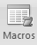
- The record macro dialog box opens.

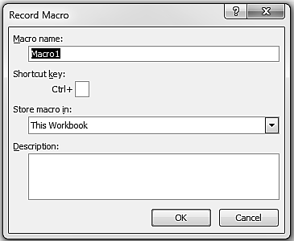
Figure 1

- In the record macro dialog box, type a name for the macro in the macro name box. Macro name must start with a letter can include letters, number, and underscore characters, but can’t include spaces.
When you click OK, the Stop Recording toolbar appears in the Code group, and you‘re ready to record. Until you stop the recording, every excel command and keystroke will be recorded in the macro, in the order in which they are entered. That means whatever operation you perform in excel in that period of time; will be recorded as VB code in one of the modules.
Let’s take a real example and learn it.
Example 1: The Birthday problem
Problem Def.: Suppose there are 32 persons having their birthday in some random order. We have to find the probability of having at least two persons having same birthday in a year.
Solution: Theoretically the probability of this problem can be done using the formula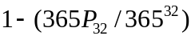. That’s a very huge calculation. This problem can be easily solved using simulation in excel. In simulation, we generate 32 persons birthday randomly and we check whether any two persons having same birthday or not. This process is repeated for large number of times. We calculate the number of times there was at least two people having the same birthday. That count divided by total number of iteration gives the real probability.
Step 1: Click on Record Macro Button in the developer tab.
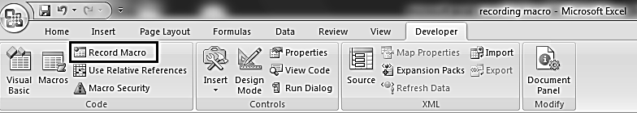
Figure 2
Step 2: The record macro dialog box open. Type the macro name you wish without space and special characters.
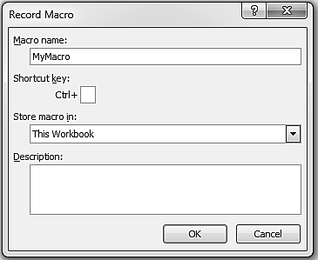
Figure 3

Step 3Click on “OK” and macro recording is started. (Note: From now whatever you do in excel will be recorded. Hence please be careful with the clicks to avoid the confusion).

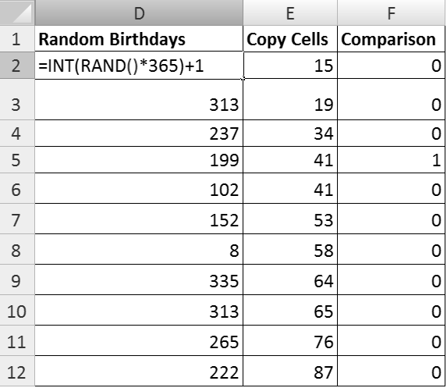
Figure 5 Excel Sheet Snapshot

Step 4: Select D2, put the formula =INT(RAND()*365)+1.Click the cell and drag the formula it till cell D33. This will be taken as the random birthdays for 32 different persons.
Step 5: Current selection will be selected from D2:D33, right click and select copy.
Step 6: Select Cell E2, right click. Dialog box opens. Click paste special, take the parameter as paste “values” and press ok.
Step 7: Keep the current selection which is from E2:E33. Right click and click on sort. Select “sort smallest to largest”. If the Sort warning comes then click on “Continue with the current selection”.
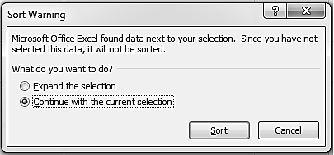
Figure 6
Step 8: Select Cell F2 and put the formula =IF($E2=$E3,1,0). Drag the formula from F2 to F33.
Step 9: Click cell F34, put the formula as=SUM(F2:F33).
Step 10: Click “Stop Recording”.
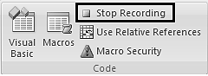
Figure 7
Step 11: Click on macro and then click on Edit button on the macro which you have recorded.
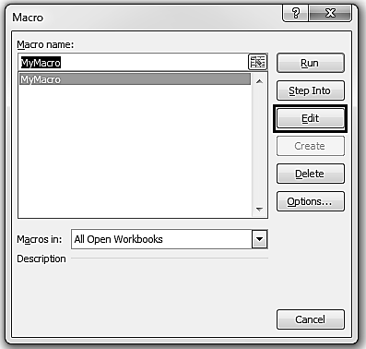
Figure 8Macro Interface

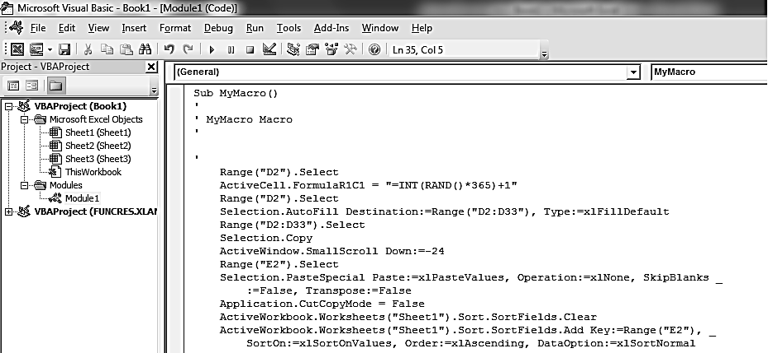
Figure 9 Visual Basic Editor

Step 12: When you click the Edit button, a Visual Basic Editor pops in and you can see your macro recorded into one of the modules. The programming language used here is VBA (Visual Basic for Application) which is almost similar to VB (If you want you can edit and delete this macro code file).
You can also the run the macro by the run button as shown in above snapshot. While running you will see that whatever operation you did while recording is now done automatically.
Step 13: To run the macro on clicking a button, you need to first create a button on the excel sheet. For this you again go to the Developer Tab and click on the Insert button in Controls group.
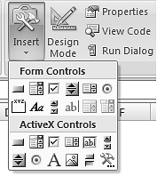Figure 11

Select the button present in the Form Controls. Draw a button with required size by dragging the mouse keeping the left click pressed. Release the click and you will see a button along with an Assign Macro pop up. This pop up is asking you to tell the macro name by which it has to associate. Here you will select the macro name which you recorded earlier.
Note: You can assign or change the macro to a button by right clicking it and choosing the Assign Macro there.
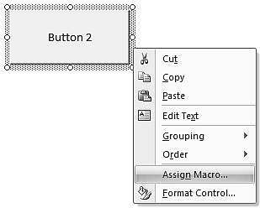 Figure 12
Step 14: Click the new button created and you will see that your macro is being called.
For the case of Birthday problem unless we carry out many experiments and get average of the probability, we will not get correct answer. Hence we need to call the entire code many times. For this we will put a while loop which will iterate till some specified number and calculate the average probability.
‘Code Modified
Sub MyMacro()
' MyMacro Macro
Dim count, i As Integer
Dim sum As Double
count = Range("K2").Value
sum = 0
i = 0
While (i < count)
‘old code as generated by macro recording
…..
If (Range("F34").Value > 0) Then
sum = sum + 1
End If
i = i + 1
Wend
Range("K14").Value = sum / count
End Sub
Here Range(“K14”).Value gets the value of cell K14 from the current active sheet.
Example 2: Randomly selecting 10 questions from 25 without repetition
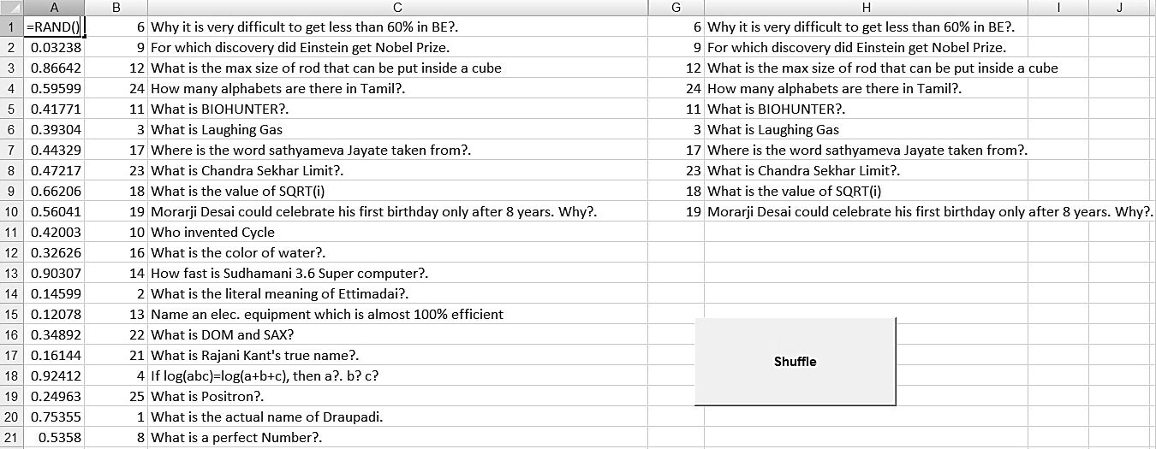
Figure 13: Randomly Selecting 10 questions from 25 Questions – Excel sheet

Step1: In A1 enter the formula =rand() and pull down the formula till A25
Step2: In B1:B25 enter 1 to 25 which represents your question No (use short cut method)
Step3: In C1:C25 Enter Questions
Step 4: Select DeveloperRecord Macro
You will be shown a Dialog box as shown in Figure 13. Change the name of Macro, if you want, and click OK button. You are now ready for recording your action.
Step 5: Select Columns A B and C and right click and click on sort button. Use custom sort (Figure 14). In custom sort select Sort by column A, sort on values and order as smallest to largest.
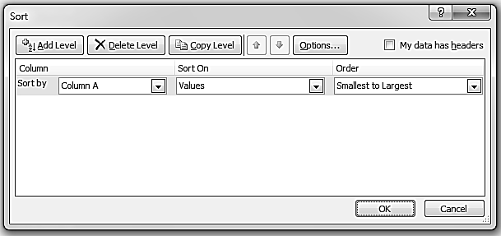
Figure 14
Step 6: From Column B and C, select first 10 rows and copy using EDITCopy
Step 7: Click in Cell G1 and do paste using EDITPaste
Step 8: Click in any cell outside the pasted array to deselect.
Step 9: Stop recording Macro by clicking “Stop Recording” button.
Step 10: Insert a Form Button as explained earlier and assign it to corresponding macro.
Step 11: Each time you click the button, you can see that you get a new set of randomly selected questions.
You have just made an Automated Question Generation utility!
Note: Macro programming is not only limited to macro recording. You can modify the code the code the way you want it to be. This requires knowledge of VBA programming.

Fractals and Macros
In the previous chapters you have seen Fractals are beautiful and they contain infinite amount of details that may not be visible by seeing once. In the following section we are going to see how we can develop fractals using excel macros. Macros will help you understand how the mathematicians have applied their logic into a computer program and get their solution more quickly and accurately. Once you gain knowledge in this area, you can extend it to drawing 3D fractals which are far more beautiful. For 3D fractals you will need high speed computers or GPU (Graphical Processing unit) to tackle with the extreme mathematical calculation they have.
As you know by now that macros bring programming power to Microsoft Office applications. The language being used to code is VBA. Let’s now see how you can create some of the common fractals (Mandelbrot, Julia and L-System) through macros and plot them to your excel sheets.
Mandelbrot
Do you remember them (Figure 1)? We drew them in our previous chapters without using any external code or macros.

Figure 1 Mandelbrot 1024x1024 with 64 Iteration
There are two files in CD for Mandelbrot using macros. Both the files differ in the way the fractal is plotted. In Mandelbrot_Macro.xlsm file, for plotting the fractal VBA function “Selection.Cells.Offset(j, i).Interior.ColorIndex = color=color_value” is used. While in Mandelbrot_Macro_Conditional.xlsm, Conditional formatting (explained in previous chapters) is used for coloring the cell elements.
Figure 2 shows the Sheet1 where you will fill the initial parameters for running the code. In case you forgot what each parameter means then please refer again the chapter on Mandelbrot.
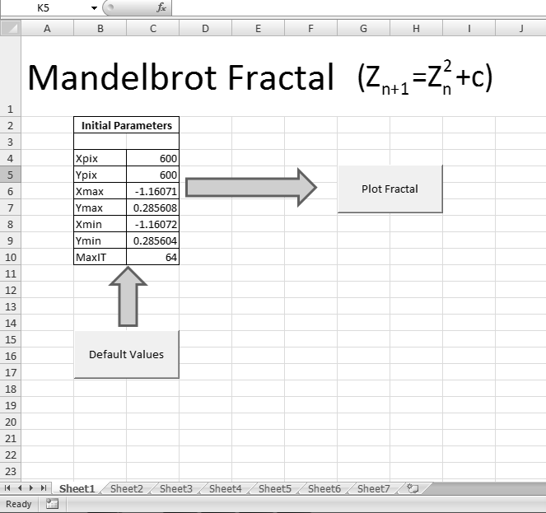
Figure 2
Running the code
Step1: Click on the “Default Values” button to populate the default parameter values for plotting the Mandelbrot. You can also put the values you wish but remember that the value of (Xmax, Ymax) should be below the range (2, 2) and (Xmin, Ymin) as (-2,-2). This is the range in which Mandelbrot function is defined. For other parameters there are no constraints.
Note: If you give a higher value for Xpix, Ypix or MaxIT (Maximum Iteration), the time required for plotting the fractal will increase accordingly.
Step2: Now you can click on the “Plot Fractal” button and see your fractal drawing on a new sheet being created.
Step3: Once the plotting is over, you can see a “Zoom” button present there. You can select any region inside the new fractal using the mouse. After selection, click to the zoom button and see the expanded fractal just created onto a new sheet.
Step4: Step3 can be repeated many times till you get error message that “No more zoom is available due to loss in precision”. This comes because the variable inside the code are not able to hold very small values which require high precisions.
Note: The zooming facility will only work correctly for last fractal being drawn. This is because the macro code that we have written stores only the coordinate of the last drawn fractal. If you wish you can change it for working for all.
Snapshots of Mandelbrot using the VBA function
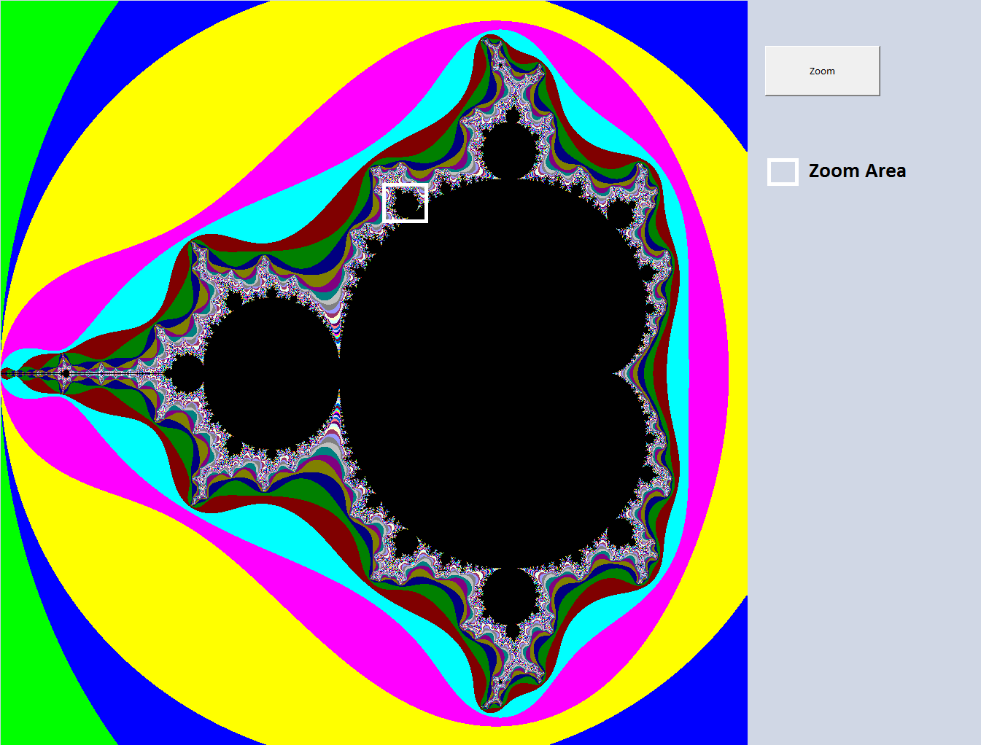
Figure 2

Figure 3 First level Zoom

Figure 4 Second Level Zoom
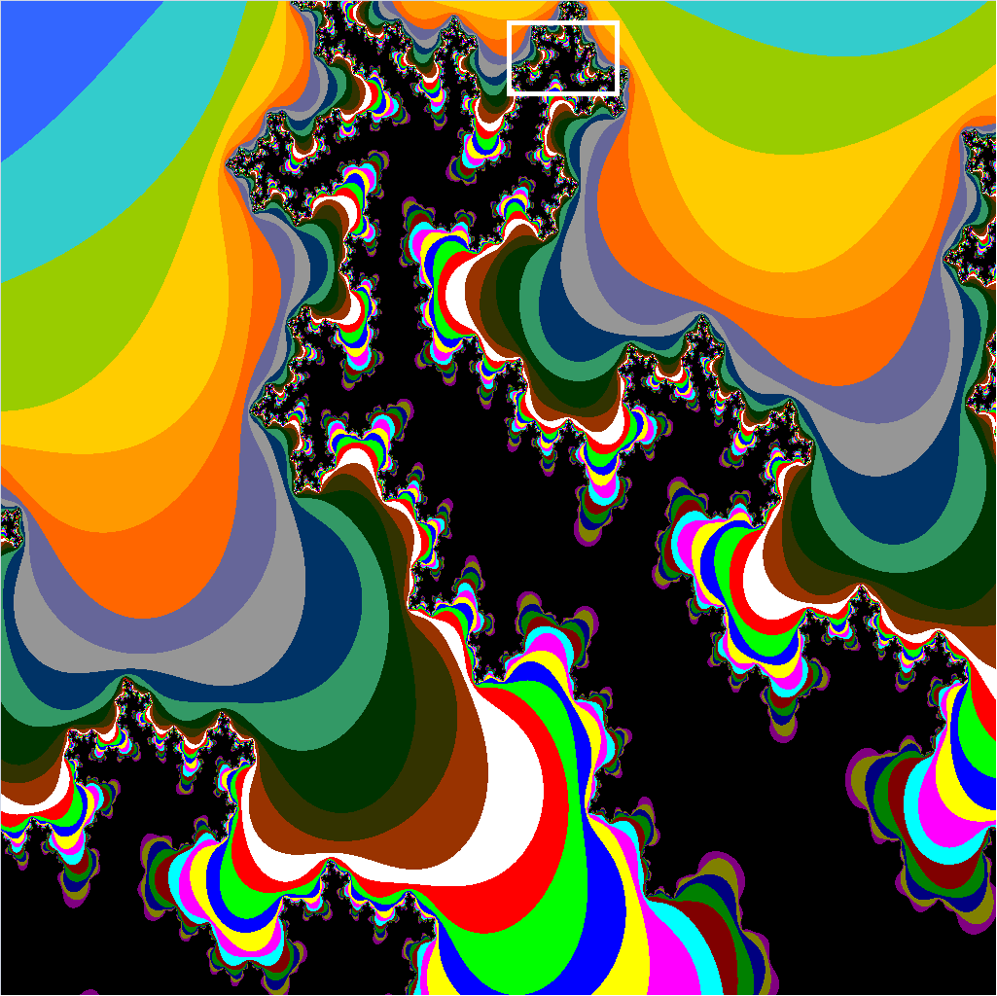
Figure 5 Third Level Zoom

Figure 6 Fourth Level Zoom

Below are the Snapshots taken by the conditional formatting code.

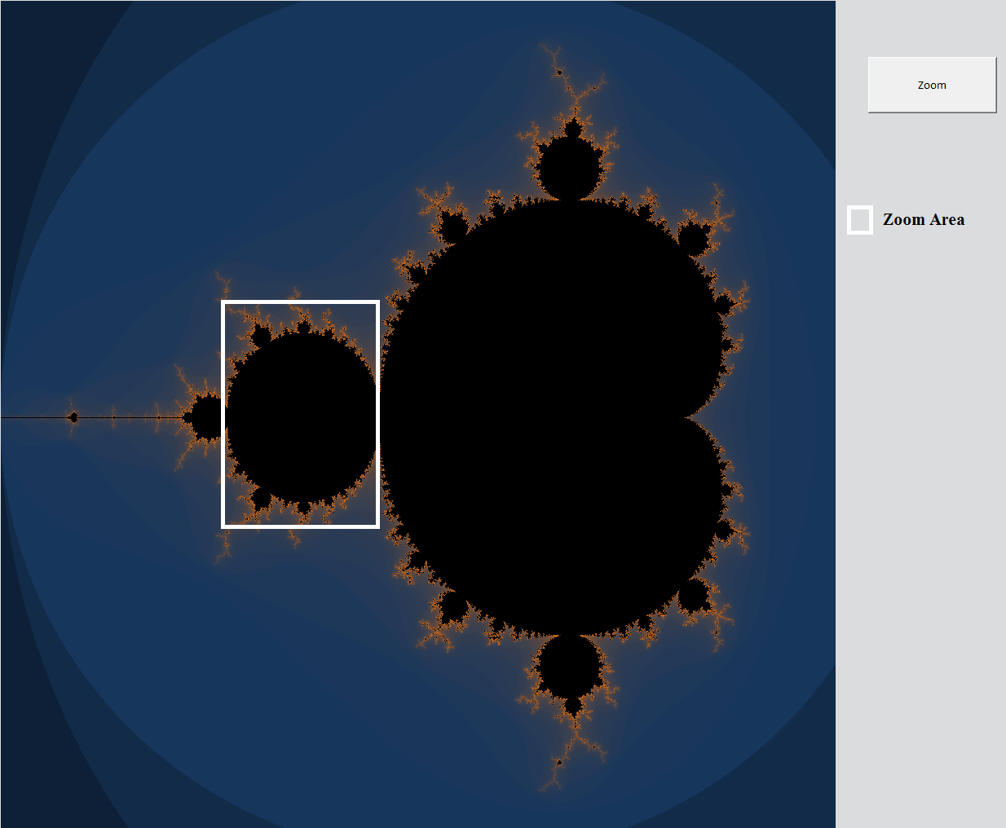
Figure 7

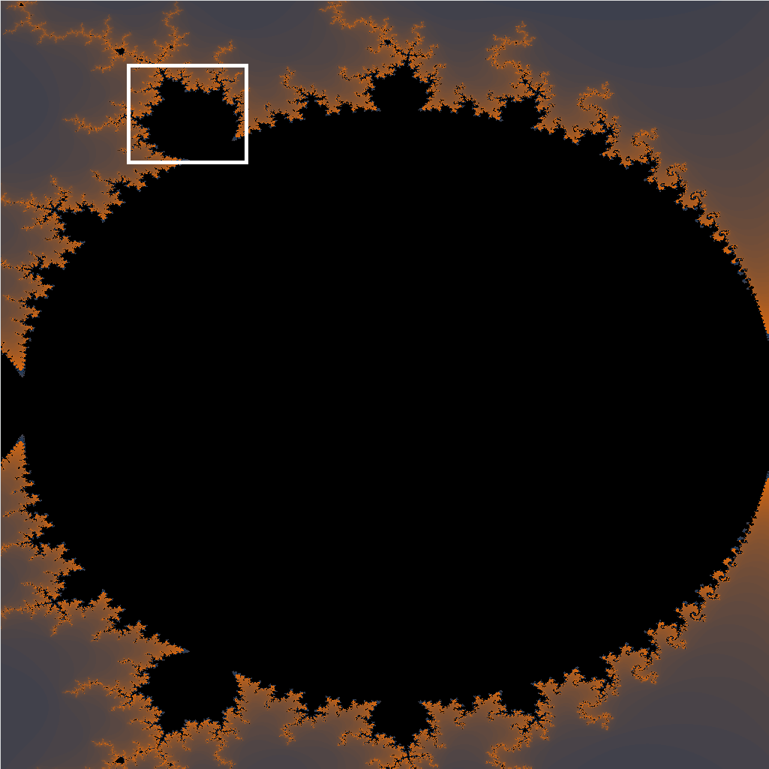
Figure 8 First Level Zoom
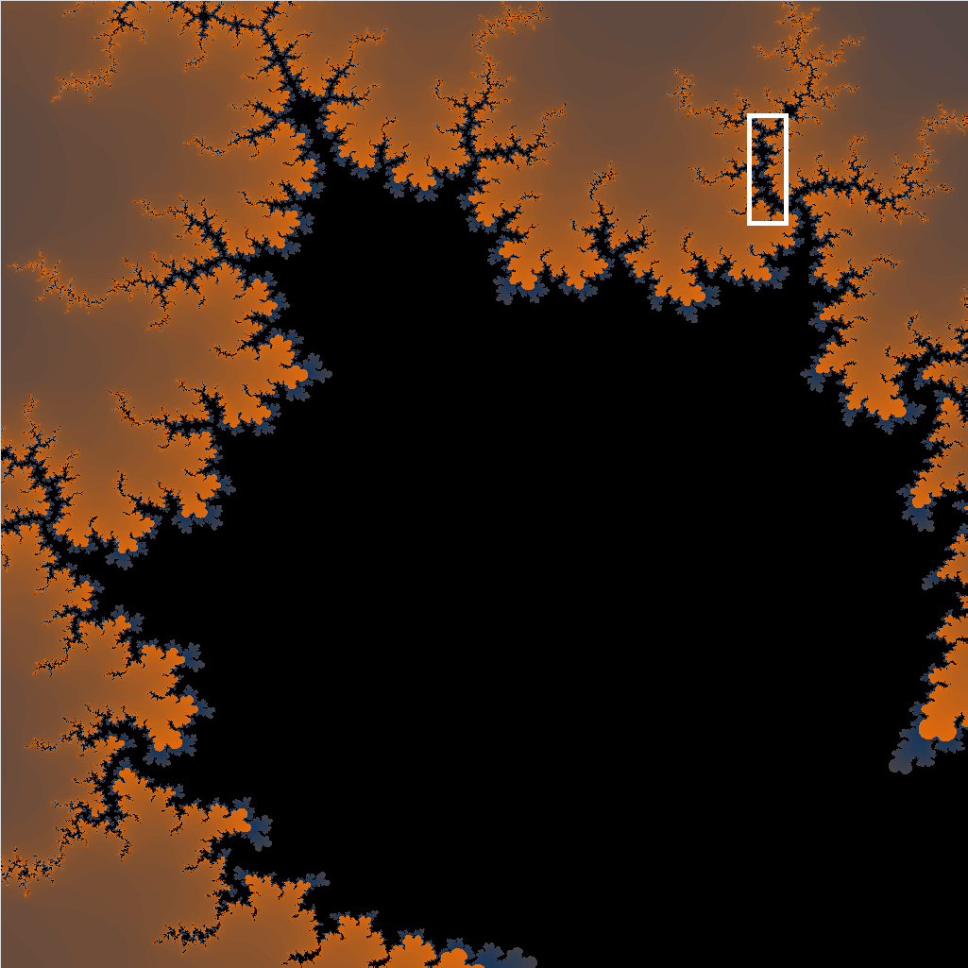
Figure 9 Second Level Zoom

Understanding the code
By now you will know how to open macros and edit them. Open the visual basic editor (shortcut key ALT+F11) and click the module 1 present in the Project Explorer. If you don’t see the Project Explorer then, from the View menu, choose Project Explorer (CTRL+R). In module 1 you can see the code written in Subroutines.
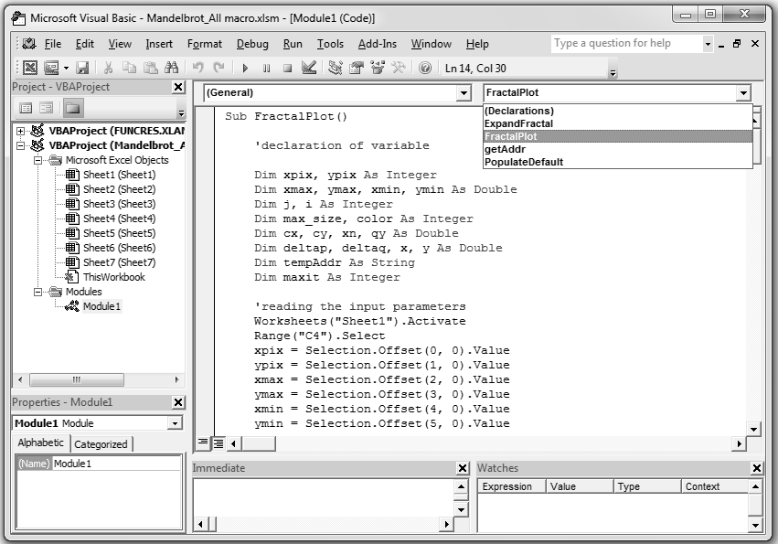
Figure 10
Subroutine FractalPlot: It is the main subroutine which does the following steps in order
Step1: Declaration of all necessary variables.
Step2: Reading all the input parameters given in Sheet1 like Xpix, Xmax, Xmin, MaxIT etc.
Code snippet
Range("C4").Select
xpix = Selection.Offset(0, 0).Value
…
Step3: Adding a new sheet and selecting the plot area in it. For better clarity of the image the size of each cell is reduced.
Code snippet
'Adding a new sheet for plotting the current fractal
Sheets.Add After:=Sheets(Sheets.Count)
'getting the plot area in terms of excel ranges
tempAddr = "A1:" & getAddr(xpix, ypix)
Range(tempAddr).Select
'reducing the cell size for better clarity of the plot
Selection.RowHeight = 1
Selection.ColumnWidth = 0.1

Step4: For each data point in grid, at max 64 iteration are done to check at which instance does the value increases than a threshold. Here the threshold is fixed to 2. The no. of iteration required is copied to color variable. The color is then restricted to 52 color values by doing the Mod 52 operation. Based on the color value each cell is colored using VBA color function for cell.
Code snippet
'Mandelbrot recursion
For i = 0 To xpix - 1
For j = 0 To ypix - 1
cx = xmin + i * deltap
cy = ymax - j * deltaq
color = 1
x = 0
y = 0
For k = 1 To 64
xn = x
x = cx + x * x - y * y
y = cy + 2 * xn * y

If (x * x + y * y > 4) Then
color = color + 1
Exit For
End If
color = color + 1
Next k
If (color >= maxit) Then
color = 1
Else
color = color Mod 52 + 2
End If
'using excel function for coloring the cell
Selection.Cells.Offset(j, i).Interior.ColorIndex = color
Next
Next

Step5: Adding a new button in the sheet, assigning the macro to subroutine “ExpandFractal” and renaming the button name to “Zoom”.
Code snippet
'adding a new button and associating it with ExpandFractal Subroutine for zooming
ActiveSheet.Buttons.Add(384.75, 42, 117.75, 51).Select
Selection.OnAction = "ExpandFractal"
Selection.Characters.Text = "Zoom"

Subroutine ExpandFractal:
This subroutine is used for the zooming functionality.
Step1: Capture the current selection area by the user. The selection area is returned in form excel cell addressing. The start range and end range address is separated by a colon. Hence we split it to get the individual address. E.g. A1:D10.
Code snippet
'getting range for user selected area
zoomRange = Split(Selection.Address, ":")

Step2: Reading the parameters of the last fractal plotted from the sheet1.
Step3: Cell address for the start range and end range are converted in the form of data point (Xmin, Ymin) and (Xmax, Ymax) respectively.
Code snippet
'X coordinates
x_point1 = xmin + (startRange.Column - 1) * deltap
x_point2 = xmin + (endRange.Column - 1) * deltap
'Y coordinates
y_point2 = ymax - (startRange.Row - 1) * deltaq
y_point1 = ymax - (endRange.Row - 1) * deltaq
Step4: Printing the new data points onto the sheet1 parameter column and calling the “FractalPlot” again.

Subroutine PopulateDefault:
This routine populates the default values for the Mandelbrot fractal.
Subroutine getAddr:
The input to this function is a row number and column number of the excel sheet. The code converts it into the corresponding excel cell address. For e.g. if you pass (1, 2) then the return value will be $B$1. The code uses Mod 26 operation to convert numbers into the alphabet system.

Understanding Conditional Formatting Code
The entire code used is same as the above except the plotting method. In this we use excel’s inbuilt Conditional Formatting operation. During the main loop, color values are put into a two dimensional array called outArray. Once the iteration is finished, the array is copied directly to the excel sheet. After that conditional formatting code is executed.
Below is the code snippet used:-
‘copying array into excel sheet
Range(tempAddr).Select
Selection.Value = outArray

'Coloring the cells using excel Conditional formating
Selection.FormatConditions.AddColorScale ColorScaleType:=3
Selection.FormatConditions(Selection.FormatConditions.Count).SetFirstPriority
Selection.FormatConditions(1).ColorScaleCriteria(1).Type = xlConditionValueLowestValue
With Selection.FormatConditions(1).ColorScaleCriteria(1).FormatColor
.ThemeColor = xlThemeColorLight1
.TintAndShade = 0
End With
You may be thinking how to remember this difficult code. Actually you don’t have to, except the basic coding syntax like for loop, while loop, if syntax, reading data from excel sheet, declaration and use of variables. The rest of code you can generate by macro recording. Easy isn’t it! For e.g. if you want to know the macro code for conditional formatting, all you need is to do a macro recording and perform a conditional formatting operation manually. Once recording is over, you can see the background code and copy the same logic to your some other code. That’s all. Learning in this way is fun indeed.
Julia Set
As you know that Julia Set is a special form of Mandelbrot in which a region inside the Mandelbrot fractal is expanded and plotted. The Mandelbrot function is given as Z_{n+1}=Z²_{n}+c. In Julia Set the ‘c’ refers to the fixed value (Cx, Cy parameters present in the sheet 1) and Z is initialized to the current data point. Rest all is same like Mandelbrot fractal. Here also we have provided two ways of plotting. One is through excel’s color function and other one is through conditional formatting.
Below shown Figure 11 is the sheet1 where you will give the input parameters. Once you click the Plot Fractal button, you will see Julia set being drawn in the new sheet just created.
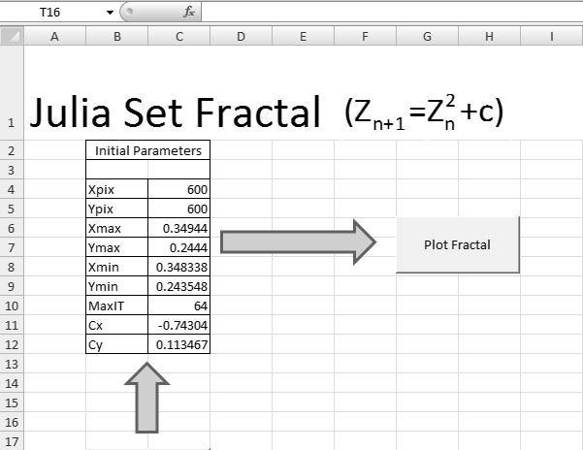
Figure 11
Shown below are the snapshots taken from Julia_Macro.xlsm and Julia_Macro_Conditional.xlsm workbooks respectively.
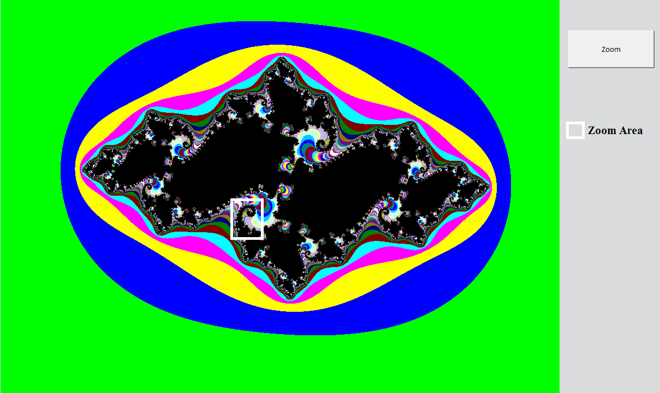
Figure 12 Level 0


Figure 13 Level 1


Figure 14 Level 2


Figure 15 Level 3
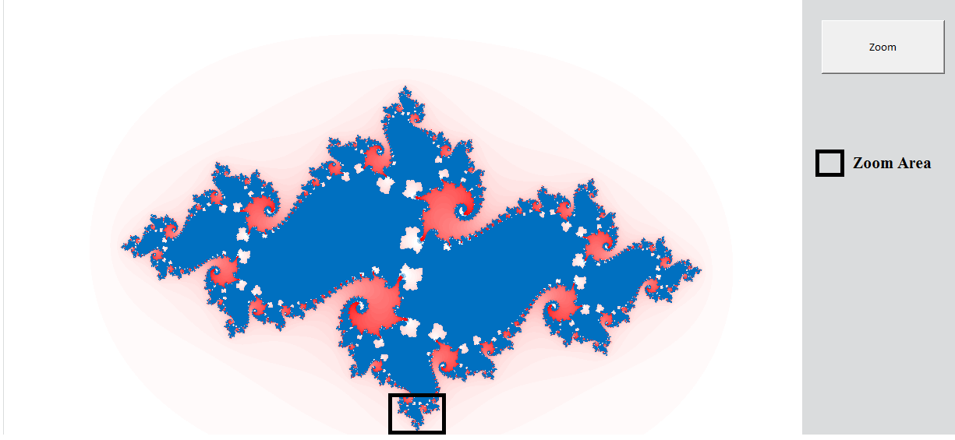
Figure 16 Level 0 using of conditional formatting
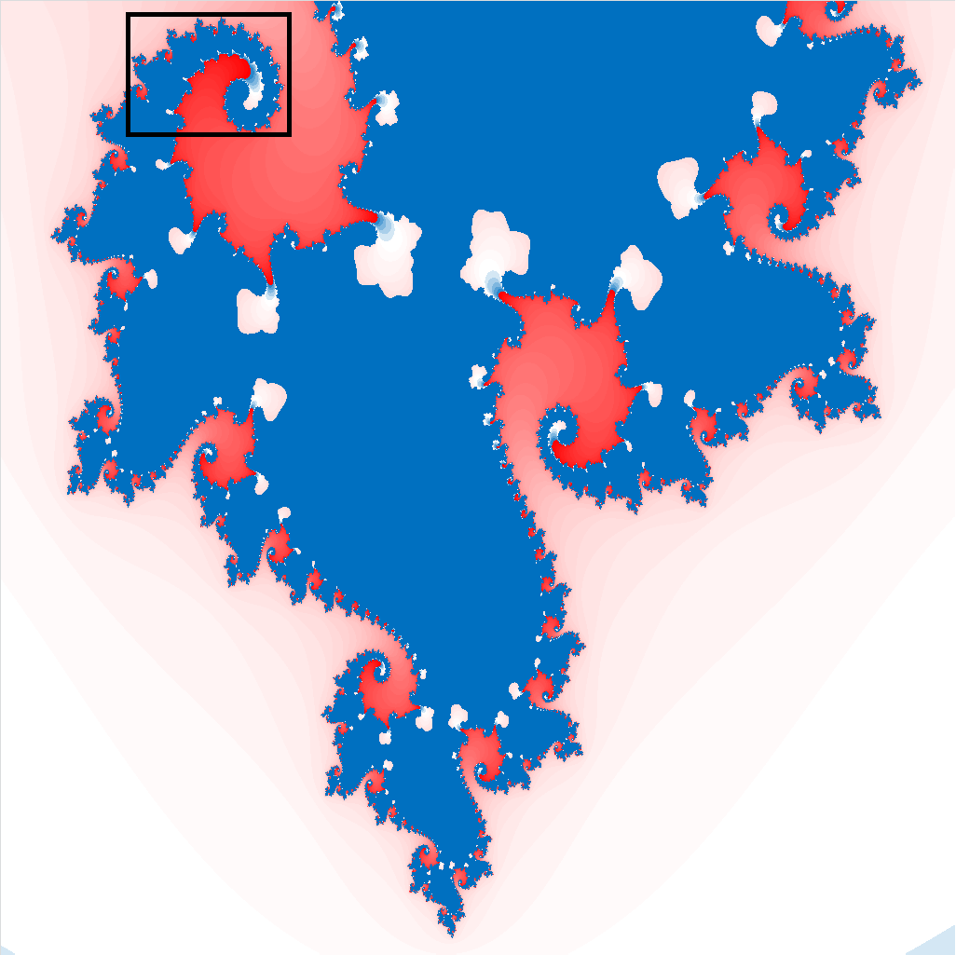
Figure 17 Level 1 conditional formatting
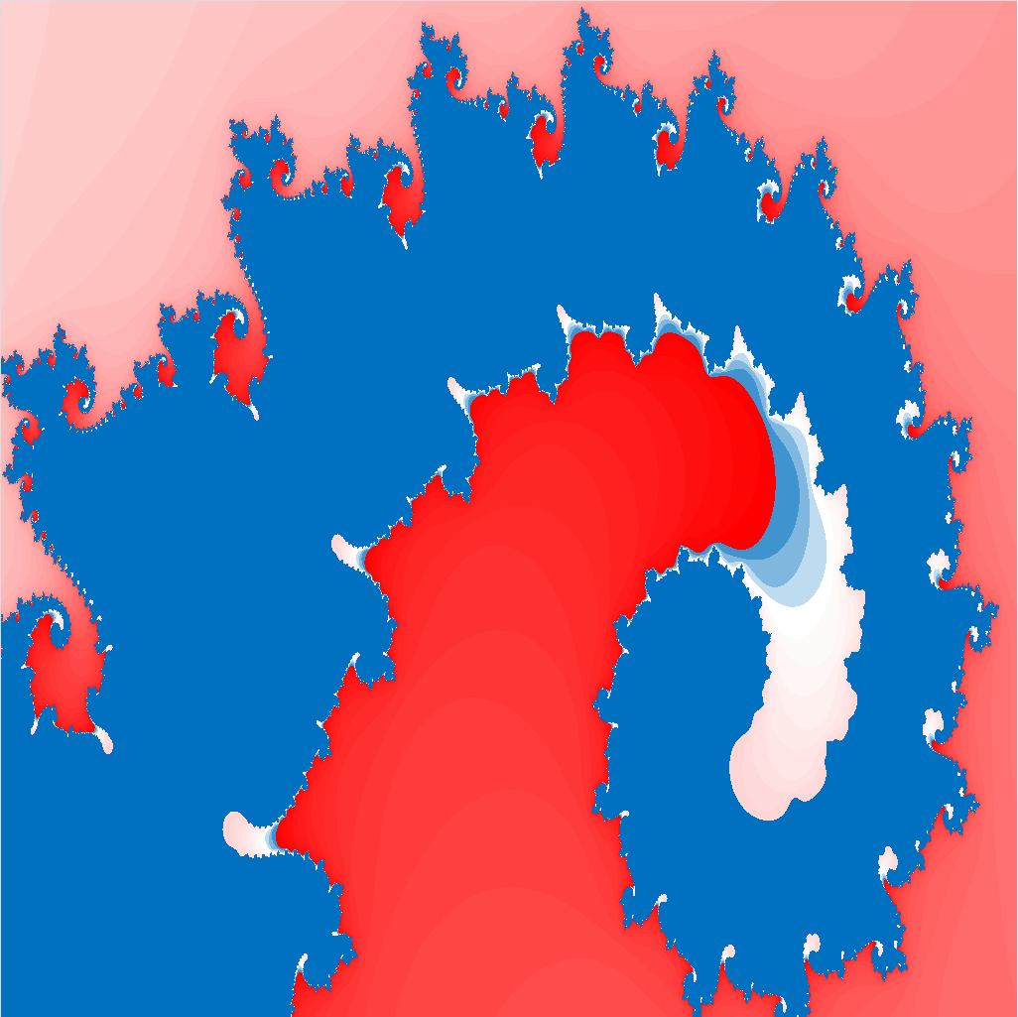
Figure 18 Level 2 conditional formatting

Understanding the code
If you have opened the macro code, you could see that it is very similar to the Mandelbrot code. Let’s mark the differences in this code.
Code snippet
'Mandelbrot recursion
For i = 0 To xpix - 1
For j = 0 To ypix - 1
cx = xmin + i * deltap
cy = ymax - j * deltaq
color = 1
x = cx
y = cy
For k = 1 To 64
xn = x
x = const_x + x * x - y * y
y = const_y + 2 * xn * y

If (x * x + y * y > 4) Then
color = color + 1
Exit For
End If
color = color + 1
Next k
If (color >= maxit) Then
color = 1
Else
color = color Mod 52 + 2
End If
'copying to outArray
outArray(j, i) = color
Next
Next
Here you can see that there are two new variables being introduced (const_x, const_y) which are Cx, Cy input parameters (see sheet1). The cx, cy variables present in the code refers to the intial value of ‘Z’. At each iteration the value of ‘Z’ is modified and checked whether it increases by a threshold value. The no. of iteration required is taken for the color calculation.

Lindenmayer System
Now you are going to see Lindenmayer systems or L-systems and how we can develop those beautiful curves and trees using programming language (Excel Macro). You will be explained a generalized code (L_System_Macro.xlsm) which will work for most of the curves and trees described in this book. Below shown are some of the curves and trees generated by the code.
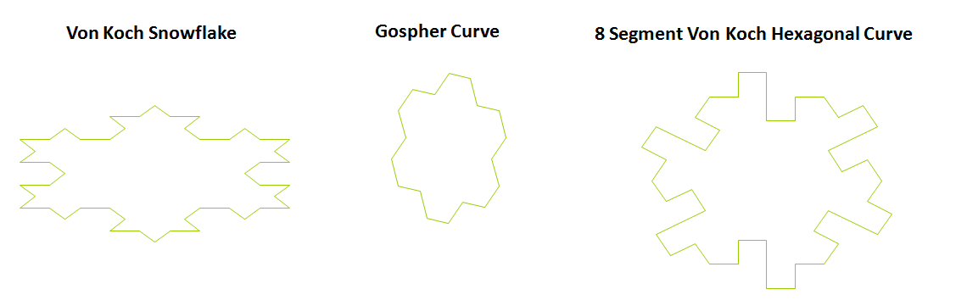
Figure 19


Figure 20

Figure 21

Lets directly go to the excel implementation. Below Figure 22 is the snapshot of ‘Parameters’ sheet where you need to fill all the necessary fields required for the L System. You will be already familiar about all these parameters and there functionalities.
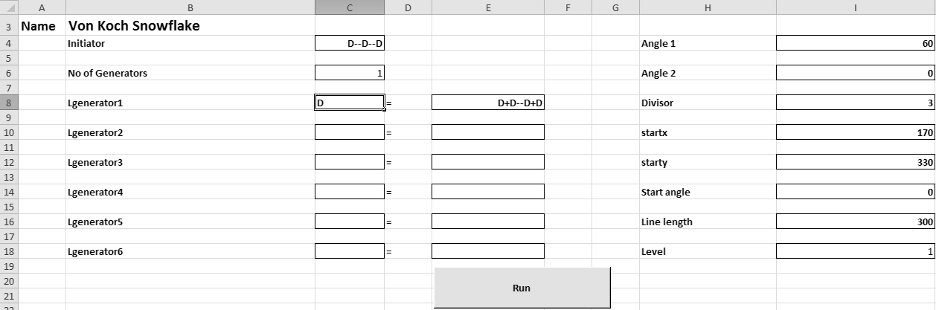
Figure 22
Once you have entered all the required fields including the level number, just press the Run button. You can see your curve or the tree being plotted in sheet called ‘Plot’.
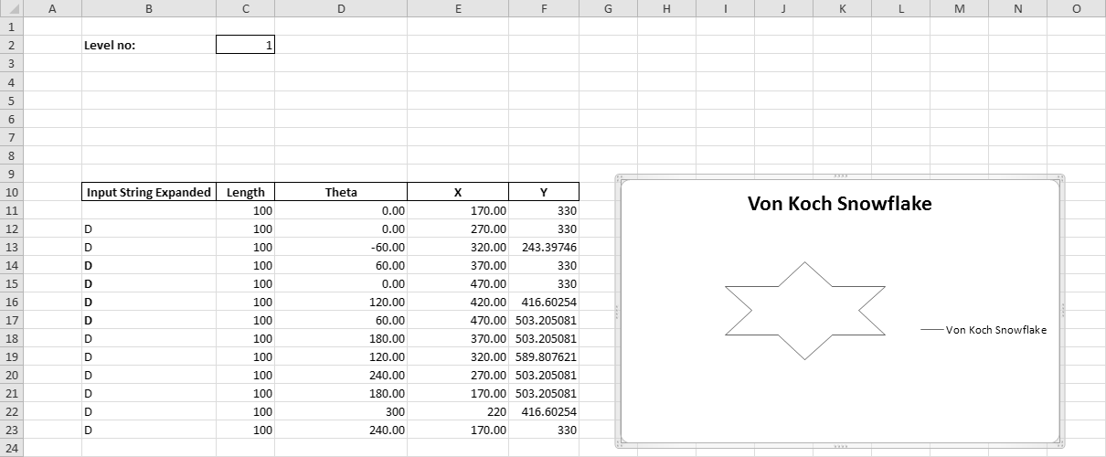
Figure 23
Understanding the code
There are four main subroutines in this code.
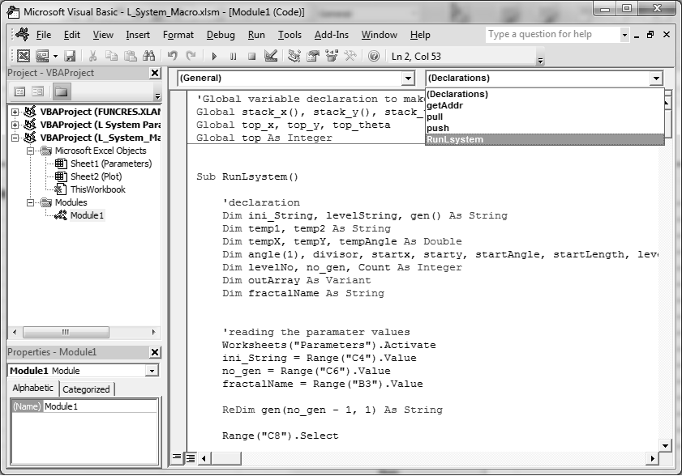
Figure 24
Subroutine RunLSystem:
This is the main subroutine which does the entire operation of L System.
Step1: Declaration of all necessary variables used by the code.
Step2: Reading all the parameters values from the sheet “Parameters” like initiator, no of generators etc.
Step3: No of generators is a changing parameter which will be given by the user. Hence based on its value, we read the generators and put it into an two dimensional array of dimension (no_gen, 1)
Code snippet
ReDim gen(no_gen - 1, 1) As String
Range("C8").Select
'reading all the generators
For i = 0 To no_gen - 1
gen(i, 0) = Selection.Offset(2 * i, 0).Value
gen(i, 1) = Selection.Offset(2 * i, 2).Value
Next i
Step4: Now we have to generate the string for the level number for which the user has requested. This is done in a level-by level fashion. i.e. if user has requested for level 3 then at first, level 1 string is created, using level 1 string level 2 string is created and so on. Below are the sub-steps:-
Ste4.1: Initializing ‘temp1’ variable to the initiator. Later on temp1 will be replaced by the generators. Generators are replaced in the order they are put in the excel sheet. We have used a For loop to iterate on all the generators. There is one important thing to handle here. Suppose we need to create Sierpinski Triangle for which the initiator and the generators are:-
Initiator: L
Lgenerator 1: L= +R-L-R+
Lgenerator 2: R= -L+R+L-
The level 1 string will be +R-L-R+ where we have replaced the initiator with the Lgenerator 1. Level 2 string will be to replace L and R together in the level 1 string. Since in VB we do one operation at a time, first we will replace L and then R. Here there is one problem. When we replace L, we will get string which may have R also. Therefore when we go for replacing R we will replace the R letter which was generated by last L replacement. That is wrong. The trick that we use here is to replace all R letters present in the replacement of L with some temporary letter and then once we complete R substitution, we will replace temporary letter with the R letter. Hence our problem is solved. In code, we use the temporary letter as integer values.
Code Snippet
While i <= levelNo
For j = 0 To no_gen - 1 'iterating for total generators present.
tempSubst = gen(j, 1)
For k = j + 1 To no_gen - 1
If (gen(k, 0) <> gen(j, 0)) Then
tempSubst = Replace(tempSubst, gen(k, 0), k, 1)
End If
Next k
temp1 = Replace(temp1, gen(j, 0), tempSubst, 1) 'actual replacement of the strings
Next j
For k = 0 To no_gen - 1
temp1 = Replace(temp1, k, gen(k, 0), 1) 'replacing back the letters which we changed in the above step
Next k
i = i + 1
Wend
Step5: Decreasing the line length for each iteration
Code Snippet
levelLength = startLength / (divisor ^ levelNo)
Step6: Counting the total no of letters which we need to print in the excel sheet. We will avoid +,-,*,# since they do not change the X, Y coordinates. Remaining all letters will be printed on the sheet.
For i = 1 To Len(temp1)
If (Mid(temp1, i, 1) = "X" Or Mid(temp1, i, 1) = "Y" Or Mid(temp1, i, 1) = "D" Or Mid(temp1, i, 1) = "S" Or Mid(temp1, i, 1) = "]" Or Mid(temp1, i, 1) = "L" Or Mid(temp1, i, 1) = "R" Or Mid(temp1, i, 1) = "T" Or Mid(temp1, i, 1) = "d" Or Mid(temp1, i, 1) = "P") Then
Count = Count + 1
End If
Next i
The Mid function returns the string containing a specified number of characters from a starting position
Step7: The first index of outArray is populated with the startx, starty, startAngle.
outArray(j, 0) = " "
outArray(j, 1) = levelLength
outArray(j, 2) = tempAngle
outArray(j, 3) = startx
outArray(j, 4) = starty
Step8: This is the crux of the code where the plotting logic is written. As you know each letter indicates a particular operation in Turtle graphics. In the code we have performed the same operation. For e.g. whenever there is a ‘X’, we need to update the X and Y coordinates as shown below.
Xnew = Xold +levelLength*cos(Theta)
Ynew = Yold +levelLength*sin(Theta)
Whenever we see an + or -, the current angle should be updated accordingly. Below is the code snippet.
For i = 1 To Len(temp1)
temp2 = Mid(temp1, i, 1)
If (temp2 = "D") Then
tempX = tempX + levelLength * Cos((3.14159265358979 / 180) * tempAngle)
tempY = tempY + levelLength * Sin((3.14159265358979 / 180) * tempAngle)
outArray(j, 0) = Mid(temp1, i, 1)
outArray(j, 1) = levelLength
outArray(j, 2) = tempAngle
outArray(j, 3) = tempX
outArray(j, 4) = tempY
j = j + 1
ElseIf (temp2 = "+") Then
tempAngle = tempAngle - angle(0)
ElseIf (temp2 = "-") Then
tempAngle = tempAngle + angle(0)
……
……
…..,
Few more characters are used specific to our code like ‘d’, ‘S’ and ‘P’. ‘d’ stands for moving to a new point without drawing any line. ‘S’ stands for printing blank in the excel sheet. Letter ‘S’ helps in retracing the curves in-case of Trees which you have already gone through in some of previous chapters. Letter ‘P’ is used to print the current point but not updating the ‘X’ and ‘Y’ coordinates. This concept is has proved helpful in drawing “Von Koch Quadric Island Curve”.
Step9: Sheet named ‘Plot’ is used for printing the outArray and then plotting the XY scatter plot from the X and Y coordinates.
Step9.1 Clearing the old contents present in the excel sheet.
Note: You have to manually delete the old chart present.
Code Snippet
Range("B11").Select
Range(Selection, Selection.End(xlToRight)).Select
Range(Selection, Selection.End(xlDown)).Select
Selection.ClearContents
Step9.2: Printing all the data present in the outArray to the excel sheet.
Code Snippet
Range("B11").Select
tempAdd1 = "$B$11:" & getAddr(10 + Count, 6)
Range(tempAdd1).Value = outArray

Note: getAddr is same old function which we have explained earlier. It takes input as row no and column number and returns it’s corresponding excel cell address.

Step9.3: Plotting in excel
Remember the below code looks scary but it can be generated easily using macro recording.
Range("M11").Select
ActiveChart.ChartType = xlXYScatterLinesNoMarkers
ActiveChart.SeriesCollection(1).Select

We are first adding a empty chart in excel using the code
ActiveSheet.Shapes.AddChart.Select

After that we add a new series and give it the name given by the user in Parameters sheet.
ActiveChart.ChartType = xlXYScatterLinesNoMarkers
ActiveChart.SeriesCollection.NewSeries
ActiveChart.SeriesCollection(1).Name = "=""" & fractalName & """"

The X and Y axis range of the chart are set using the below code
tempAdd2 = "$E$11:" & getAddr(10 + Count, 5)
tempAdd3 = "$F$11:" & getAddr(10 + Count, 6)
ActiveChart.SeriesCollection(1).XValues = "=Plot!" & tempAdd2
ActiveChart.SeriesCollection(1).Values = "=Plot!" & tempAdd3
Here tempAdd2 will contain the entire range address of X value while tempAdd3 will have for Y respectively.
Step 9.4: Once the chart is plotted, we will do some beautification on it by reducing the point size and changing the color.
ActiveChart.SeriesCollection(1).Select
With Selection
.MarkerStyle = 8
.MarkerSize = xlThin
.MarkerBackgroundColorIndex = 43
.MarkerForegroundColorIndex = 43
End With
With Selection.Border
.ColorIndex = 43
.Weight = xlHairline
.LineStyle = xlContinuous
End With

Step9.4: We will also delete the grid lines and the axis lines present in the chart.
ActiveChart.Axes(xlValue).MajorGridlines.Select
Selection.Delete
ActiveChart.Axes(xlCategory).Select
Selection.Delete
ActiveChart.Axes(xlValue).Select
Selection.Delete
Step9.5: Changing the chart type to scatter lines without markers.
ActiveChart.ChartType = xlXYScatterLinesNoMarkers

Subroutine push & pop:
Both push and pop subroutine are used for generating L System trees where we need retracing while plotting. Push and Pop operation are stack operation where push means putting the current data value onto the top of the stack and pop means removing the top element in the stack. Stack is a data structure which obeys LIFO (Last in First Out).i.e. the last element present in the stack will be removed first.
In the code we have declared the variables as global so that the stack variables are accessible from both push and pop code segments.
Global stack_x(), stack_y(), stack_theta() As Double
Global top_x, top_y, top_theta
Global top As Integer

Subroutine getAddr:
The code written here is same as explained in the Mandelbrot fractal.
Figure 25 shows some more fractals generated by the code explained above:-

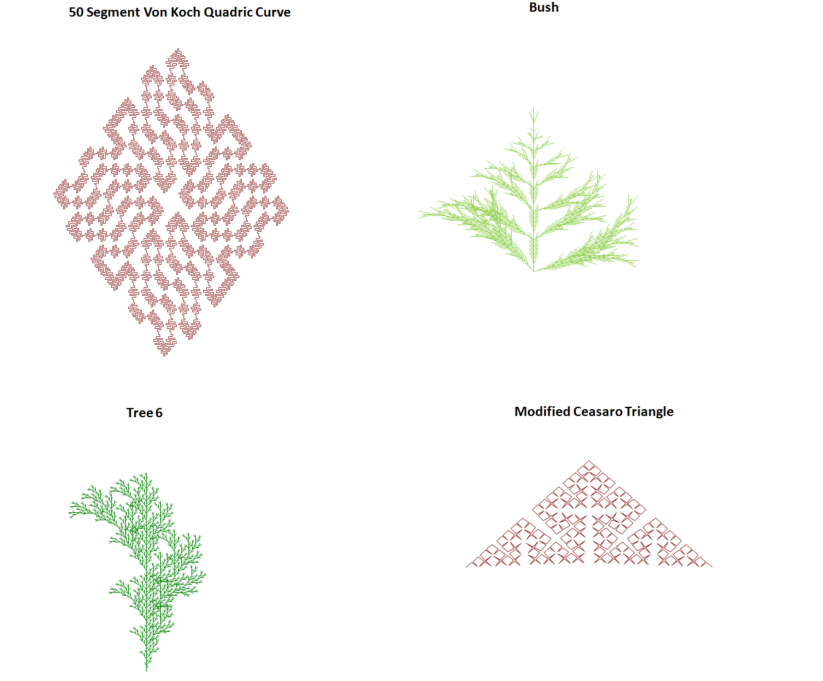
Figure 25

